Project Design Phase-II
Data Flow Diagram & User Stories

Date | 27-06-2025
Team ID | LTVIP2025TMID55137
Project Name | ShopSmart
Maximum Marks | 4 Marks

Data Flow Diagrams:
A Data Flow Diagram (DFD) illustrates how data moves within the Resolve Now platform. It captures how user interact with the system, how information flows between different components, and where the data is stored.
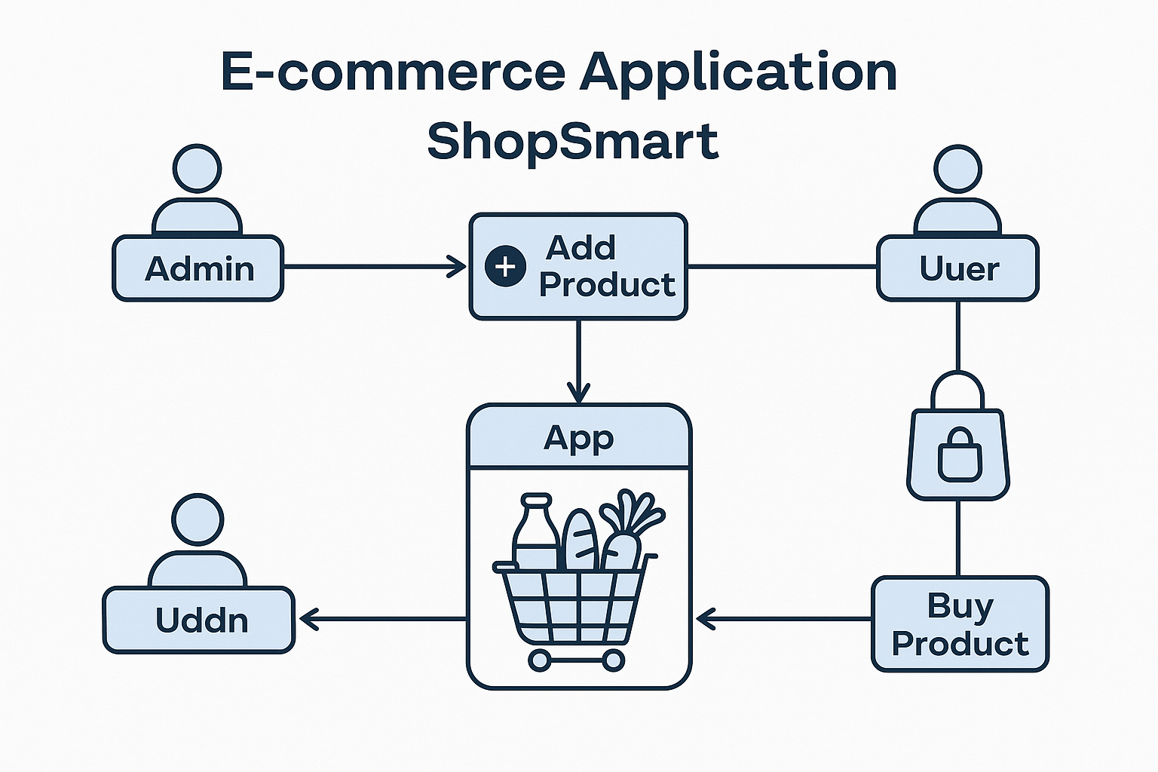

User Story Table – Shop Smart
User Type | Functional Requirement (Epic) | User Story / Task | Acceptance Criteria | Priority | Release
Admin | Product Management | As an admin, I can add new grocery products to the app. | Products appear in the product listing for users. | High | Sprint-1
Admin | Inventory Control | As an admin, I can update or delete existing products. | Changes are reflected in real-time to users. | High | Sprint-1
User | Product Browsing | As a user, I can browse all available grocery products. | All listed products are visible with details like price and quantity. | Medium | Sprint-2
Client | Add to Cart | As a user, I can add items to my shopping cart. | Selected items appear in the cart with correct quantity and total. | High | Sprint-2
Admin | Order Management | As an admin, I can view and process user orders. | Admin dashboard shows new orders and their statuses. | High | Sprint-1

